Patient Name: _____________________________________

Today I feel:
About the same _________________________________________
Somewhat improved _____________________________________
Much improved _________________________________________
No more complaints _____________________________________
Change in complaint _____________________________________
New complaint _________________________________________
Other _________________________________________________

Time of day when pain is worst: __Morning __Afternoon __Evening __Wakes Me
Does the pain radiate? ____________________________________________________
Please circle on the pain scale from 0 to 10 the pain you feel with this condition.
10 being the worst pain you have felt with this condition, 0 being no pain.
Mark areas of pain on figures below.
Type of Pain: __Stiffness __Burning __Numb/Tingling __Sharp __Soreness/Achy

Pain Chart
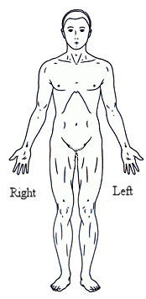 | 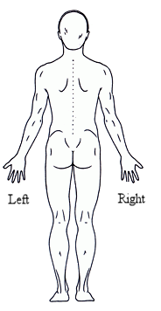 | Neck Pain  0 1 2 3 4 5 6 7 8 9 10  Shoulder, Arm Pain  0 1 2 3 4 5 6 7 8 9 10  Mid Back Pain  0 1 2 3 4 5 6 7 8 9 10  Low Back Pain  0 1 2 3 4 5 6 7 8 9 10  Hip, Leg Pain  0 1 2 3 4 5 6 7 8 9 10  Foot, Ankle Pain  0 1 2 3 4 5 6 7 8 9 10  Other Pain  _________________

Date: ________________________ Signature ___________________________

