Stretch Exercises
- Each exercise should be held for 20 seconds, followed by a 5 second relaxation period.
- Each exercise should be done at least 3 times.
- Do this routine once a day or as specified.
Gastrocnemius (calf); Soleus (calf); Quadriceps (front of thigh)

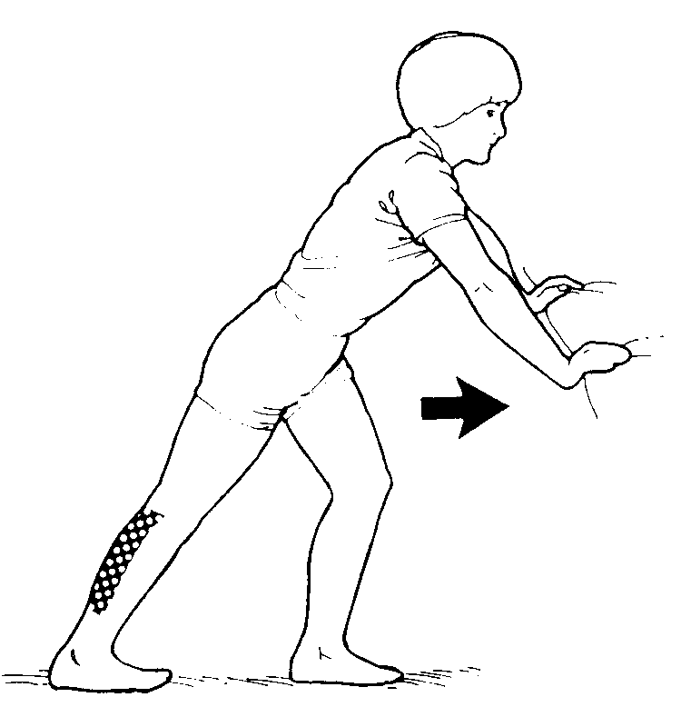 | Gastrocnemius (calf)  Lean against a wall with your back leg straight and your front leg slightly bent. Keep your back heel on the floor and lean progressively closer to the wall until you can feel the stretch in your calf. Repeat with other leg.

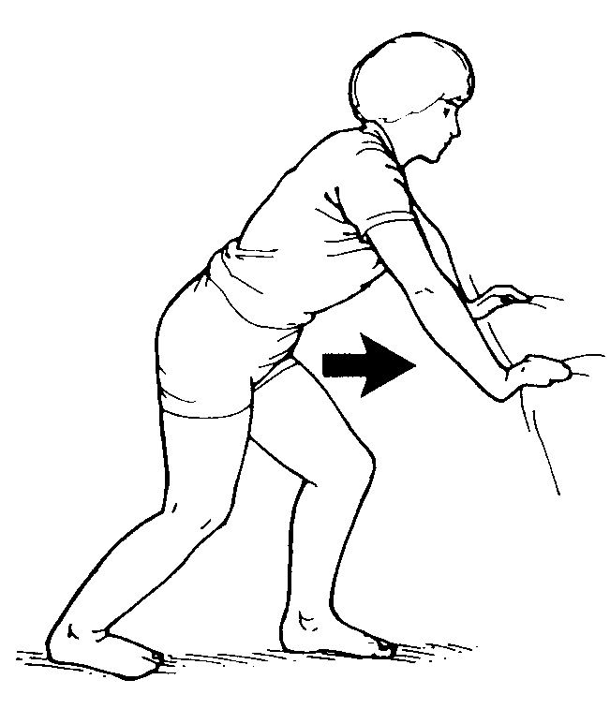 | Soleus (calf)  Lean against a wall with both your back leg and your front leg slightly bent. Keep your back heel on the floor and lean progressively closer to the wall until you can feel the stretch in your calf. Repeat with other leg.

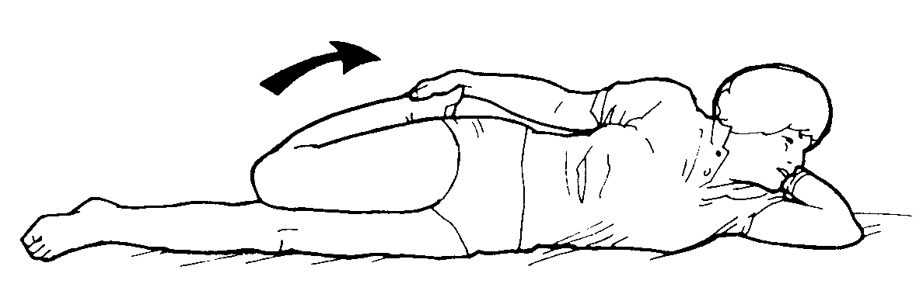 | Quadriceps (front of thigh)  Lying on your side, reach back and grab your upper foot and pull it up toward your buttocks. Repeat with other leg while on your other side. Keep your knees together.

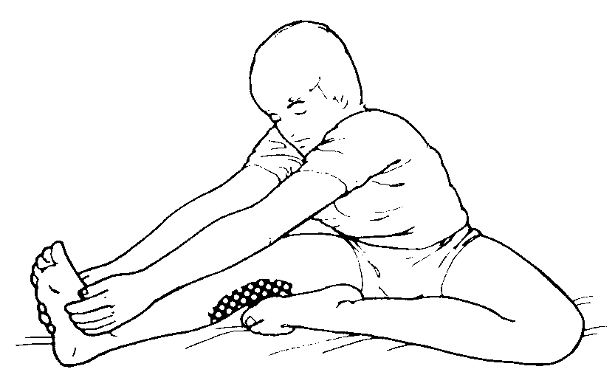 | Hamstrings (back of thigh)  Sitting, bring the sole of your bent leg to the inner thigh of your straight leg. Lean forward and grasp the ankle of your straight leg with both hands. Keeping the leg straight, pull your upper body down towards your feet.

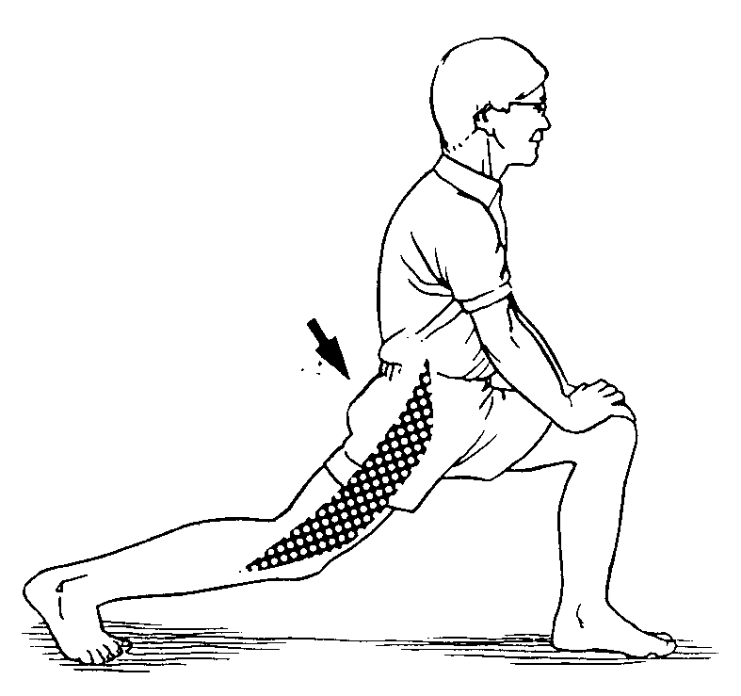 | Hip Flexors (front of hip)  Move your hip forward, keeping the upper body straight up and the back leg stretched out. Feel the tightening in the hip and hold the position. The stretch can be accentuated by putting the back knee on the ground. Keep the front knee directly above the foot.  Don't keep the front knee at such an angle that it is in front of the ankle, since this hinders the real stretch in the hip.

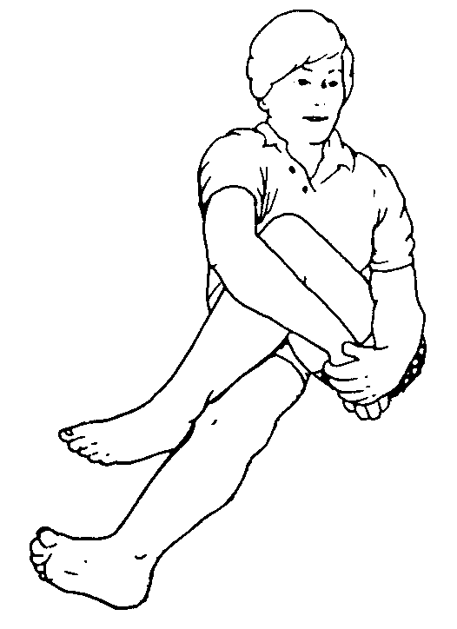 | Gluteals and Hip  Sitting, bend one leg and cross it over the other leg which is either straight or lying on its side bent at 90 degrees. Push the opposite elbow against your bent knee and force buttocks to table.

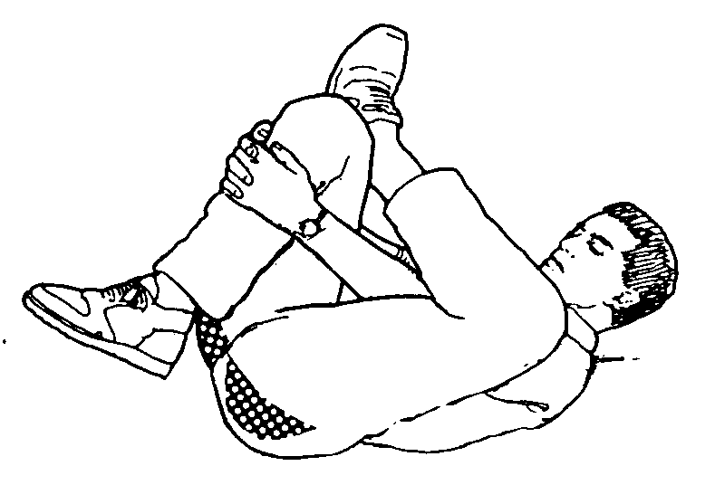 | Gluteus Maximus (buttocks)  Lying on your back with both knees bent, cross the left leg over the right. Using both hands pull your right knee toward your chest. You should feel a stretch in the buttocks on your left side. Repeat on opposite side.

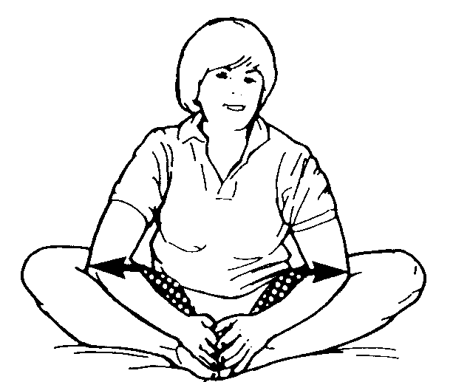 | Hip Adductors (groin)  Sitting, bend both legs and put the soles of your feet together. Grab your feet with both hands. With your elbows, push out against the insides of your knees.

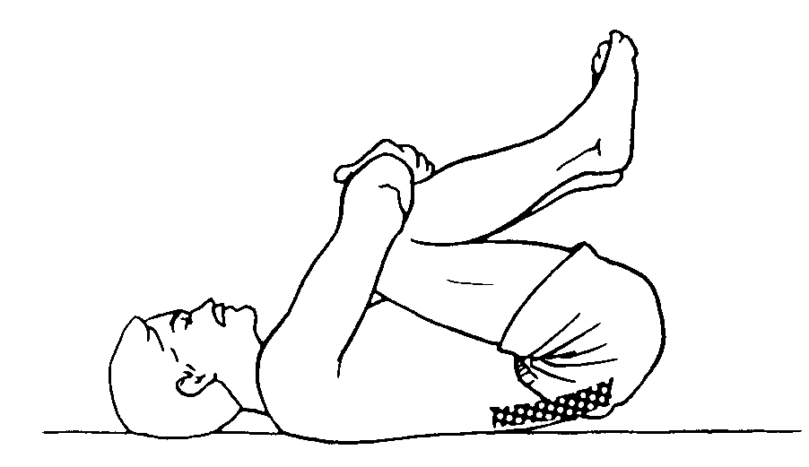 | Erector Spinae (low back)  Bring both knees to the chest by first raising one and then holding the knee with both hands. Then raise the other knee. Grasping both knees, pull them down to the chest. Relax.

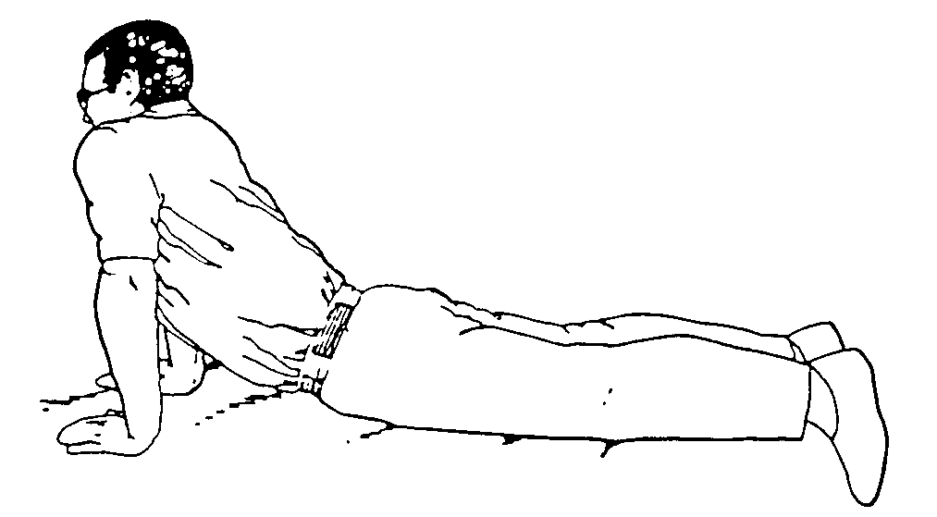 | Spinal Extension (prone press-ups)  Lie on stomach with palms by shoulders up while keeping pelvis on the surface; back and stomach sagging. Slowly lower shoulders. Repeat 10 times, sustaining the up position for several seconds during the last few repetitions.

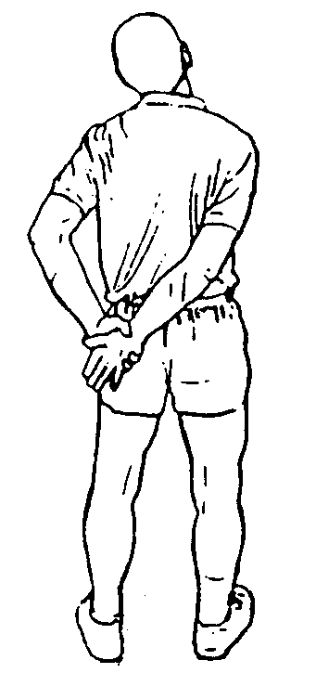 | Supraspinatus (superior shoulder)  Place involved hand behind your back and grasp hand with other hand. Pull diagonally down and across back. Tilt head toward the uninvolved shoulder. You should feel the stretch across the top and front of your shoulder.

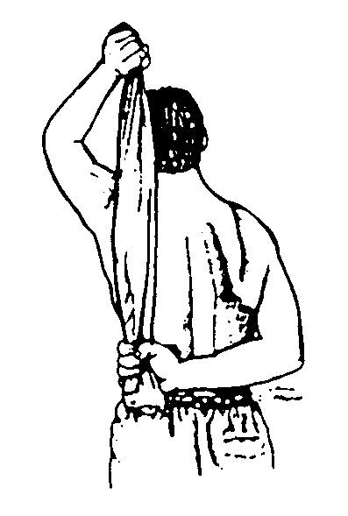 | Rotator Cuff (internal rotation)  Place a towel in both hands. Position your involved arm behind your back at waist height and your uninvolved arm up and overhead. Slowly pull the towel upward. You should feel the stretch in the front and back of your shoulder.

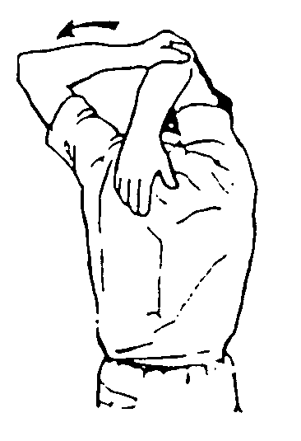 | Triceps and Teres Major (shoulder girdle)  Raise one arm up and behind your head. With the opposite arm grasp your elbow and pull the arm further behind your head.

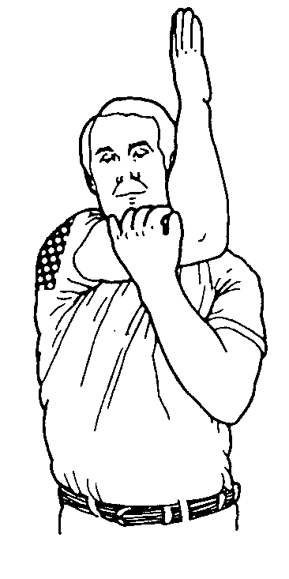 | Infraspinatus and Teres Minor (shoulder rotator cuff)  Lying on your back or sitting, reach arm across chest toward opposite shoulder as far as possible. With opposite hand, grasp the elbow and pull the arm across even further. Externally rotating the arm during this stretch emphasizes the teres minor.

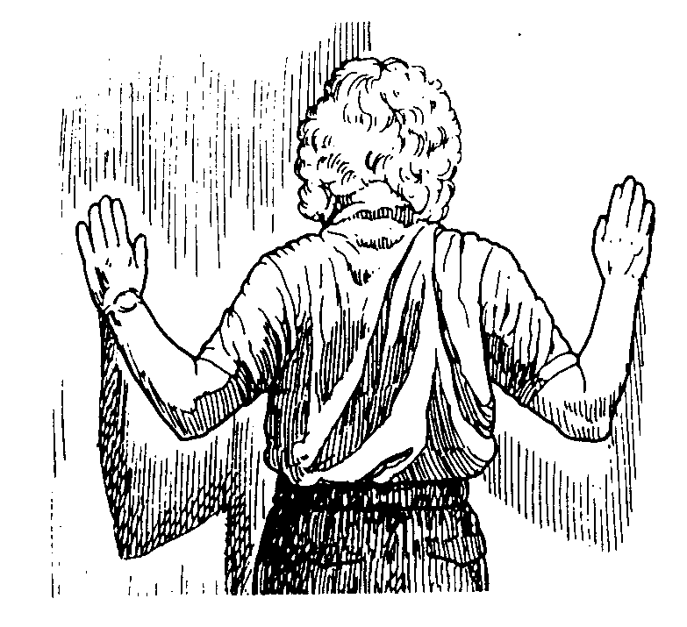 | Pectoralis Major (chest)  Stand with your forearms against the wall in a corner of the room. Gently lean forward until you feel a stretch in the front of your shoulder and chest. This can be done one arm at a time by placing one forearm up against a wall and turning your chest away from the wall until you feel a stretch.

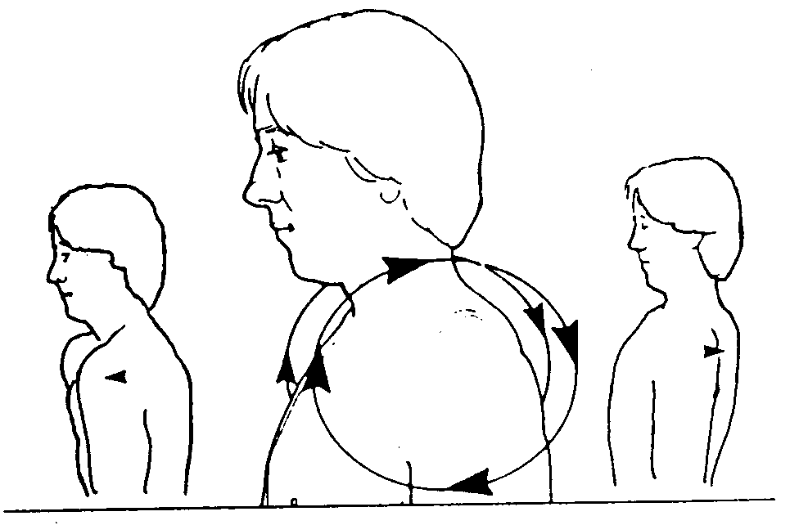 | Shoulder and Neck (tension relievers)  Roll shoulders slowly backward. Do it 4 times.
